Fault Detection And Monitoring For Industrial Motor

Pranjali.A.Bandgar
Department of Electronics and Telecommunication Engineering, Kasegaon Education Society's Rajarambapu Institute of Technology, affiliated to Shivaji University, Sakharale, MS-415414, India.
2205033@ritindia.edu
Rushikesh.L.Jankar
Department of Electronics and Telecommunication Engineering, Kasegaon Education Society's Rajarambapu Institute of Technology, affiliated to Shivaji University, Sakharale, MS-415414, India.
2005021@ritindia.edu

Ashlesha.A.Nikam
Department of Electronics and Telecommunication Engineering, Kasegaon Education Society's Rajarambapu Institute of Technology, affiliated to Shivaji University, Sakharale, MS-415414, India.
2208062@ritindia.edu

Dr. Sanjay. S. Pawar
Associate Professor
Department of Electronics and Telecommunication Engineering, Kasegaon Education Society's Rajarambapu Institute of Technology, affiliated to Shivaji University, Sakharale, MS-415414, India.
sanjay.pawar@ritindia.edu

Harshvardhan.D.Sakale
Department of Electronics and Telecommunication Engineering, Kasegaon Education Society's Rajarambapu Institute of Technology, affiliated to Shivaji University, Sakharale, MS-415414, India.
2105002@ritindia.edu

Abstract— This paper presents the design and implementation of a proof-of-concept (PoC) open-source data logger system for real-time fault detection and predictive maintenance of industrial electric motors. The system is developed using embedded systems and integrates a Raspberry Pi to enable advanced data processing and intelligent diagnostics using machine learning. It collects and analyzes sensor data in real-time from thermistor sensors, piezoelectric sensors, speed sensors, current sensors, and voltage sensors. The sensors monitor critical motor parameters such as temperature, vibration, and electrical characteristics in hybrid or enclosed motor environments. Thermistors detect overheating caused by shaft overloads, insulation failure, or bearing wear. Piezoelectric sensors are used to detect vibrations and mechanical stress, providing key insights into issues such as shaft misalignment, unbalanced loads, and improper mounting. Current and voltage sensors help identify electrical faults like overcurrent, undervoltage, and phase imbalances. This can indicate issues in the motor’s power system, helping to assess cooling system efficiency and potential overload conditions. A Raspberry Pi is embedded in the system to handle sensor interfacing, real-time data logging, and implementation of predictive maintenance algorithms. The algorithms detect early-stage faults and provide timely maintenance alerts to reduce downtime and enhance motor reliability. By using open-source hardware and software, the system offers a cost-effective, scalable, and adaptable solution for both industrial monitoring and academic research. Lab tests validate its effectiveness for continuous condition monitoring and intelligent fault detection in electric motor applications.
Keywords— Data Logging, Fault Detection, Industrial Motor, Predictive Maintenance, Raspberry Pi.
- INTRODUCTION
Electric motors are essential components in industrial systems, powering machinery and automation across various sectors. Ensuring their reliability and operational efficiency is critical, as motor failures can result in significant downtime, financial losses, and safety hazards. Traditional maintenance practices, such as scheduled servicing or manual inspections, are often reactive and may fail to detect early signs of mechanical or electrical faults. To address these limitations, industries are shifting toward predictive maintenance strategies that rely on real-time monitoring and intelligent fault detection.

The paper presents the design and development of a real-time fault detection and predictive maintenance system for industrial electric motors using embedded systems and a Raspberry Pi [1]. The system integrates multiple sensors, including a piezoelectric sensor (for vibration analysis), a thermistor (for temperature monitoring), a current transformer (for current sensing), and a voltage sensor, to monitor the motor’s environment. These sensors work together to detect faults such as overheating, misalignment, excessive vibration, overload, and poor ventilation—common issues that affect motor performance.
A PIC18F4550 microcontroller is used to acquire and preprocess Digital sensor data. This data is then transmitted to a Raspberry Pi via a PL2303 USB-to-serial interface. The Raspberry Pi, equipped with a 32GB SD card and Wi-Fi connectivity, acts as the central processing unit. It performs data logging, real-time visualization, and predictive maintenance using intelligent algorithms.
This open-source, cost-effective system provides continuous condition monitoring and early fault detection, reducing unplanned downtime and maintenance costs. It is highly adaptable and suitable for both research and industrial deployment.

FAULT DETECTION SYSTEM
The rapid advancement of embedded system technologies has enabled the development of intelligent monitoring systems capable of detecting and diagnosing equipment faults in real time. These systems integrate multiple sensors and communication networks to continuously track critical parameters such as vibration, temperature, voltage, and current, ensuring optimal performance and safety of industrial machinery.

A. System Architecture and Components
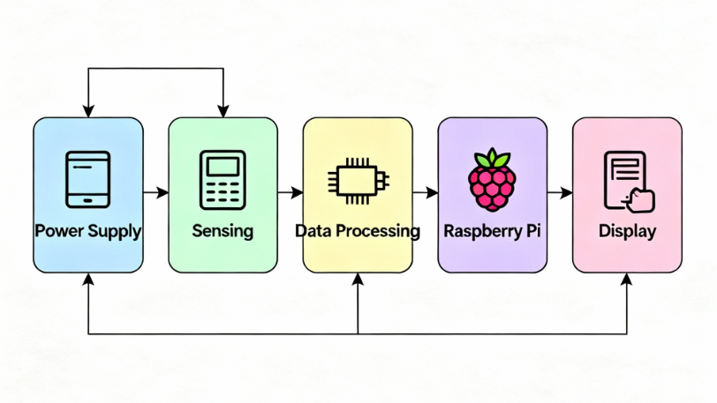
Figure 1: System Architecture of Fault Detection for Industrial Motor
The proposed system adopts an approach by implementing an embedded IoT-based architecture for real-time fault detection and predictive maintenance of industrial motors. It utilizes a PIC18F4550 microcontroller for sensor data acquisition and preprocessing, and a Raspberry Pi for centralized processing, data visualization, and intelligent fault prediction through Wi-Fi-enabled communication. Figure 1 illustrates the complete system flow.
1. Sensing Block
- Voltage Divider Circuit
This reduces the high-voltage input signal to a lower voltage suitable for analog-to-digital conversion by the microcontroller.
- ACS712 Current Sensor
A Hall-effect-based sensor that detects current flowing through a conductor and outputs an analog signal proportional to that current. It ensures galvanic isolation and safe measurement [2].
- Thermistor Temperature Sensor
A thermistor is used as the temperature sensor, whose resistance changes with temperature. The microcontroller measures this resistance variation to monitor motor overheating [3].
- Piezoelectric Vibration sensor
A piezoelectric vibration sensor is used, which generates a voltage when subjected to mechanical vibrations. The microcontroller processes this signal to detect misalignment or abnormal motor vibrations [4].

2. Processing and Control Block
- PIC18F4550 Microcontroller
It handles analog signal acquisition from the sensors, converts it using the built-in 10-bit ADC, calculates real-time electrical parameters, and manages data flow to the LCD and Wi-Fi module [5].

3. Output and Communication Block
- UART (Universal Asynchronous Receiver/ Transmitter) Communication
UART communication is used to transfer sensor data from the PIC18F4550 microcontroller to the Raspberry Pi. It ensures reliable, serial data exchange through the PL2303 USB-to-serial interface.
- 16x2 LCD Display
Provides a local, real-time display of voltage, current, temperature, and vibration sensor readings for on-site users.
- Raspberry Pi module4
The Raspberry Pi 4 serves as the primary processing unit for motor fault detection.
It collects and analyses sensor data received from the microcontroller via UART communication. The module also handles real-time visualization, data storage, and Wi-Fi-based remote monitoring [7].

4. User Interface
Receives data from the Raspberry Pi and offers features such as live charts, data logging, and threshold alerts.
- User Access
Remote access is provided through any device with internet connectivity (smartphone or PC), allowing monitoring and notification configuration.
5. Power Supply
- Regulated 5V/12V Power Supply
The power unit supplies 5V DC to the sensors, microcontroller, and display, while a 12V supply to the relay
- Relay
The relay acts as an automatic electronic switch, enabling the microcontroller to safely control the motor’s power circuit. It ensures that fault conditions or control commands can reliably disconnect or energize the motor as needed for protection and automation.

- Block Diagram
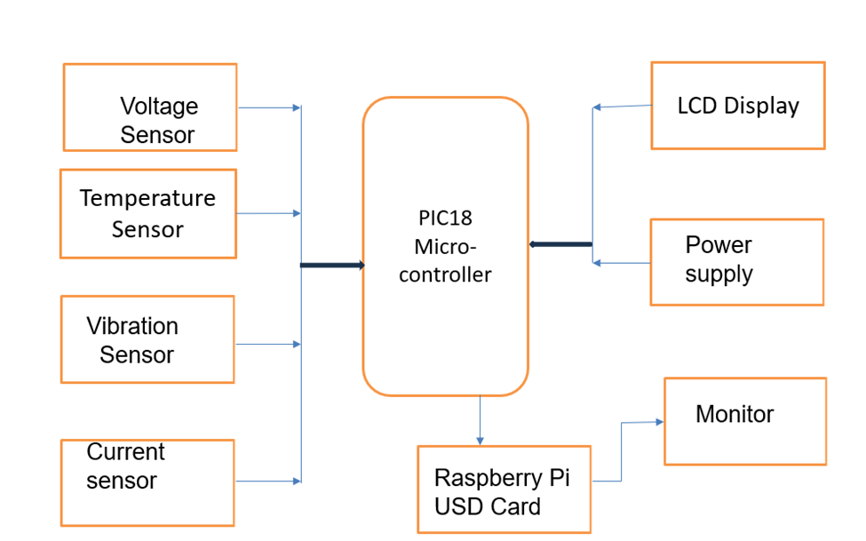
Figure 2: Block Diagram of Fault Detection for Industrial Motor System

The block diagram of the proposed fault detection system is illustrated in Figure 2. The system is designed to sense real-time voltage, current, temperature, and vibration parameters, process the data using a PIC18F4550 microcontroller, display the readings locally on an LCD 16x2, and transmit the information to a Raspberry Pi module 4 for data logging, remote monitoring, and predictive maintenance.

The sensing section consists of sensors, including a temperature sensor (thermistor) that detects overheating, a vibration piezoelectric sensor that identifies imbalance and misalignment, and current (ACS712)/voltage sensors that capture electrical faults. All the sensor outputs connect to the PIC18F4550 microcontroller, which has built-in analog-to-digital converters (ADCs) for digitizing analog sensor signals. The microcontroller processes these sensor values and updates the results on the LCD, providing real-time feedback to the user.

The system includes a Raspberry Pi with an SD (USD) card connected to the microcontroller. This setup enables storage and remote access to collected data via a monitor interface. The power supply ensures the continuous operation of all these components.

Predictive maintenance capability is implemented in this system. Continuous, real-time condition monitoring and analysis of sensor data allow the system to utilize trends and anomalies to proactively detect potential faults, anticipate failures, and trigger maintenance activities before actual breakdowns occur [9].

This block diagram presents a clear and modular system architecture, enabling robust monitoring and fault detection, real-time display, and data logging. The system is designed for scalability and future enhancements, such as advanced analytics and predictive maintenance.

CIRCUIT DESIGN OVERVIEW
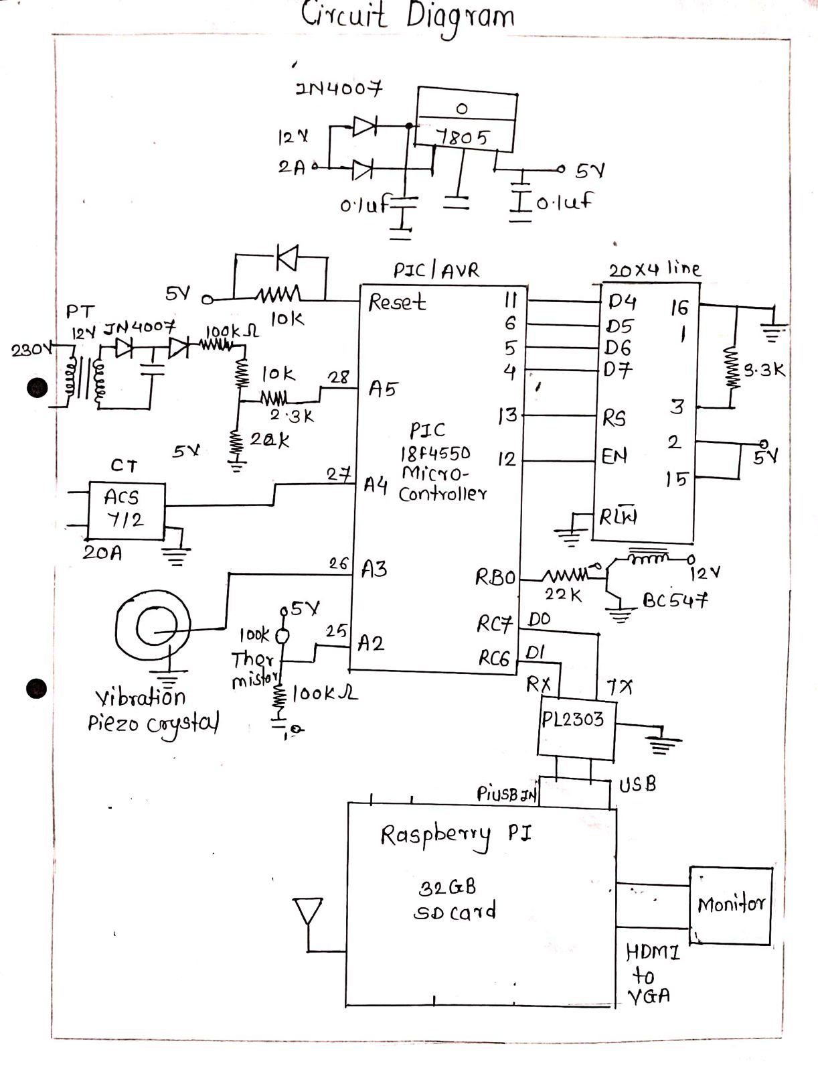
Figure 3. Circuit Diagram of Fault Detection for Industrial Motor System
The detailed circuit diagram in Figure 3 represents the complete circuit diagram of the proposed Fault detection system for the Industrial Motor. The system is designed to ensure safe sensing, reliable data processing, clear data display, and seamless communication with the Raspberry Pi. The power supply stage begins with a 230V AC mains input, which is stepped down using a transformer to 22V AC. The stepped-down AC is then rectified using a bridge rectifier made of four 1N4007 diodes and smoothed through capacitors to obtain a steady 5V DC output using a 7805 voltage regulator IC, which powers the microcontroller and related components.
In the sensing section, the current measurement is done by an ACS712 sensor integrated with a CT (current transformer), which outputs an Analog voltage proportional to the current passing through it. A vibration piezoelectric crystal sensor is connected to the microcontroller for vibration measurement. Analog signals, including those from a thermistor for temperature sensing, are fed into ADC pins of the PIC18F4550 microcontroller for processing.
The PIC18F4550 microcontroller is at the heart of the system. It receives analog input signals from all the sensors and performs analog-to-digital conversion for accurate measurement. The processed data is output in real time to a 16x2 LCD module, which displays the voltage, current, temperature, and vibration values to the user. The variable resistors (potentiometers) are used for adjusting the LCD contrast.
Simultaneously, the microcontroller interfaces with the Raspberry Pi through a PL2303 USB-to-serial converter and transmits the processed data for further handling. The Raspberry Pi uses a 32GB SD card for data storage and outputs the information to a monitor via HDMI [7] [10].
This integrated system architecture provides an efficient, real-time, and scalable solution for monitoring electrical parameters, ensuring both user convenience and enhanced energy management [8].

RESULT AND DISCUSSION

Figure 4 shows the design, development, and successful implementation of the Fault Detection System for Motors using PIC18F4550 and Raspberry Pi; the performance of the prototype was thoroughly tested and evaluated.
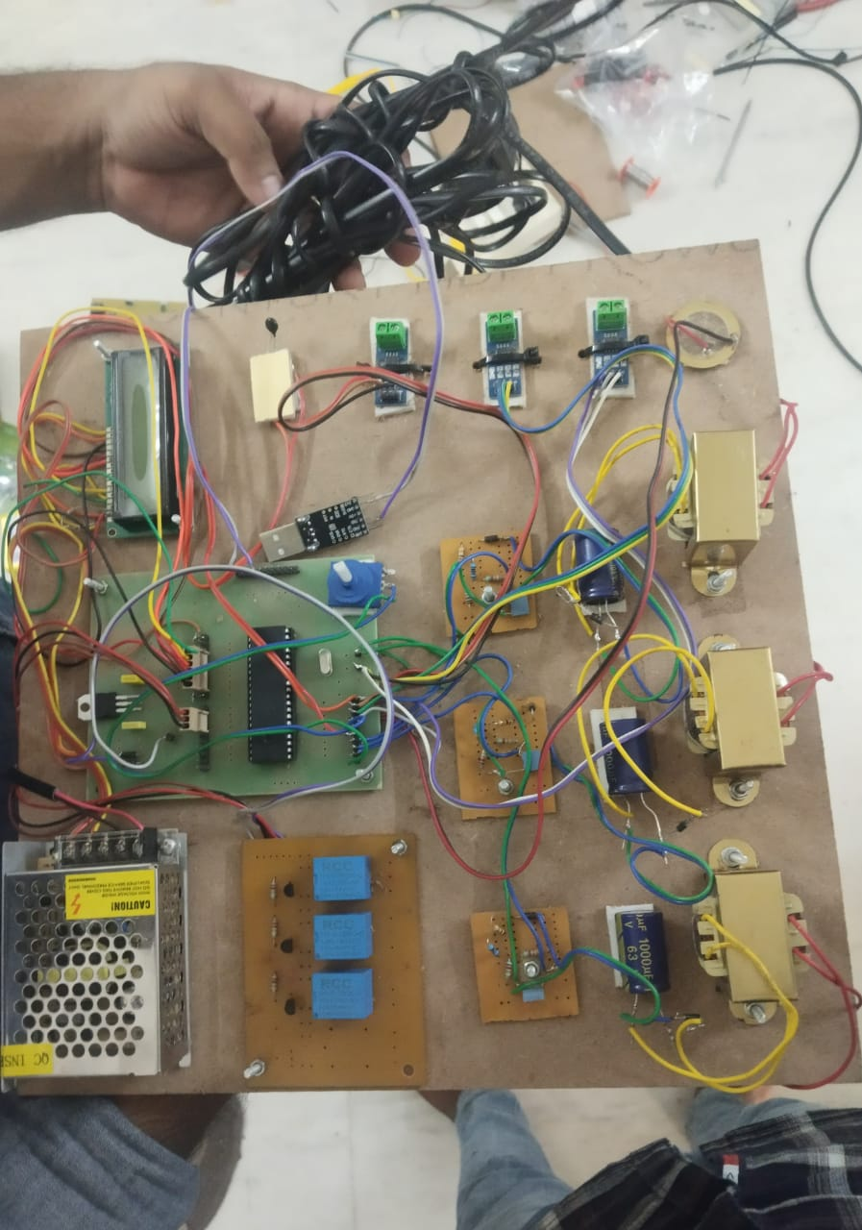
Fig.4-The Above image shows the implementation of hardware components.
Figure 4.1 The experimental setup includes the prototype mounted near the motor with sensors and electronics interfacing directly with the motor environment. The circuit board connects to key measurement points, and the LCDs display real-time values of current, voltage, temperature, and vibration for immediate monitoring.

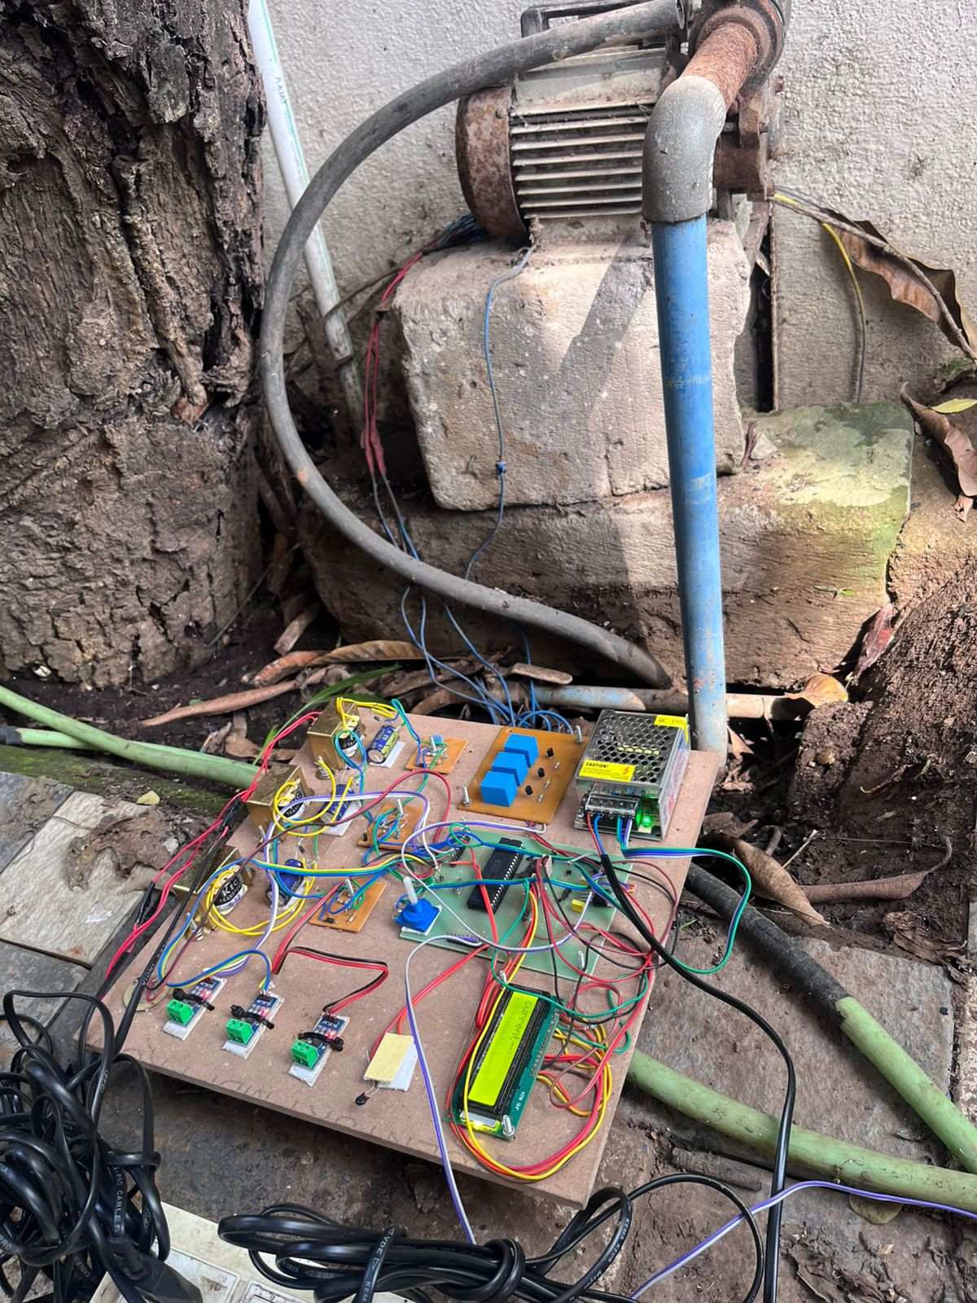
Fig.4.1-The Above image shows the prototype mounted on the motor.
In this study, fault detection thresholds were established based on standard operational limits and sensor characteristics. The voltage fault threshold was set at 12 V, the current at 20 A, the temperature at 70°C, and the vibration at 0.6 g. These values represent the maximum safe operating limits beyond which potential equipment failure or hazardous conditions may occur. Setting accurate thresholds is critical for reliable detection and timely fault intervention.

Figure 4.2 The system displays real-time vibration data on the LCD, confirming successful sensor integration and live monitoring capability

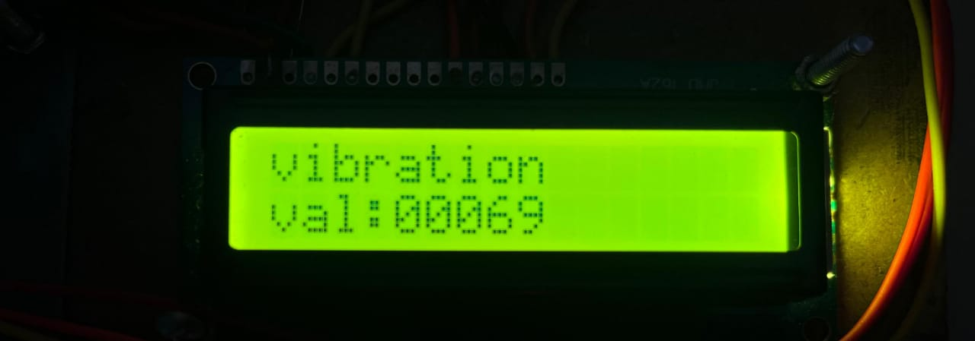
Fig.4.2- Reading of the Vibration Sensor.

Figure 4.3.1-4.3.2 3 shows the system displaying real-time voltage readings for phases R, Y, and B on the LCD screen.
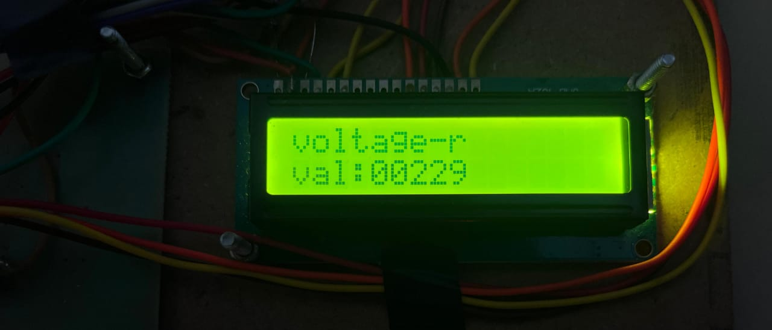
Fig.4.3.1-Reading of the Voltage-r Sensor.
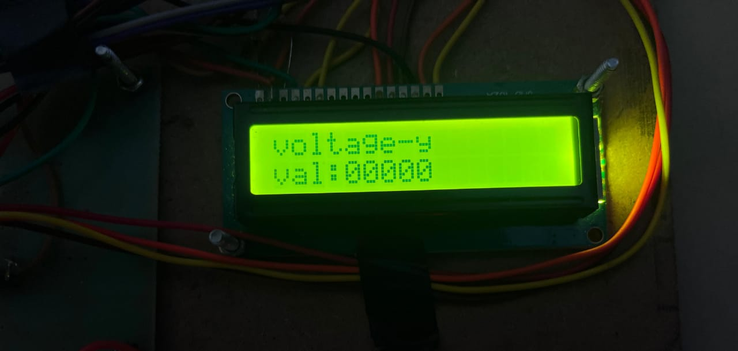
Fig.4.3.2 -Reading of the Voltage-y Sensor.
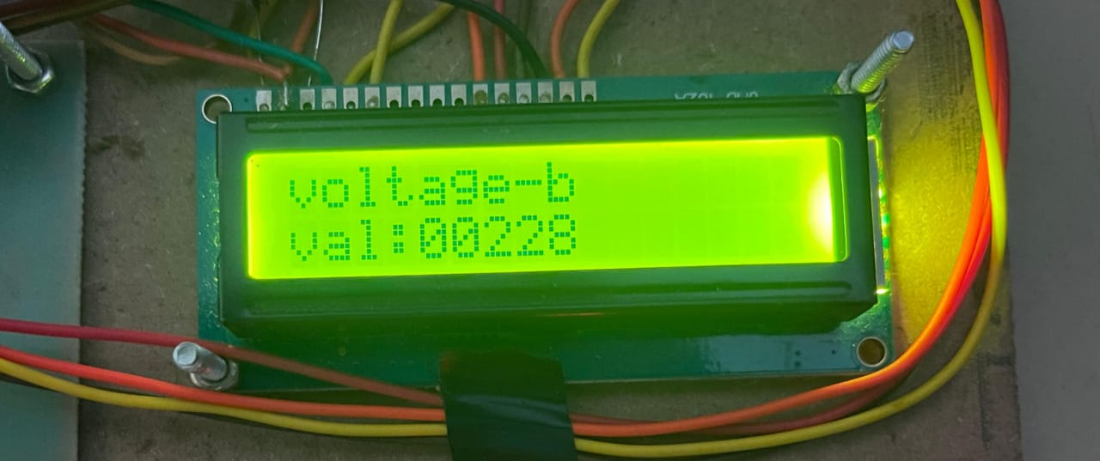
Fig.4.3.3 - The reading of the Voltage-b Sensor.

Figure 4.4.1-4.4.3 shows the system displaying a real-time Current reading for phases R, Y, and B on the LCD screen.

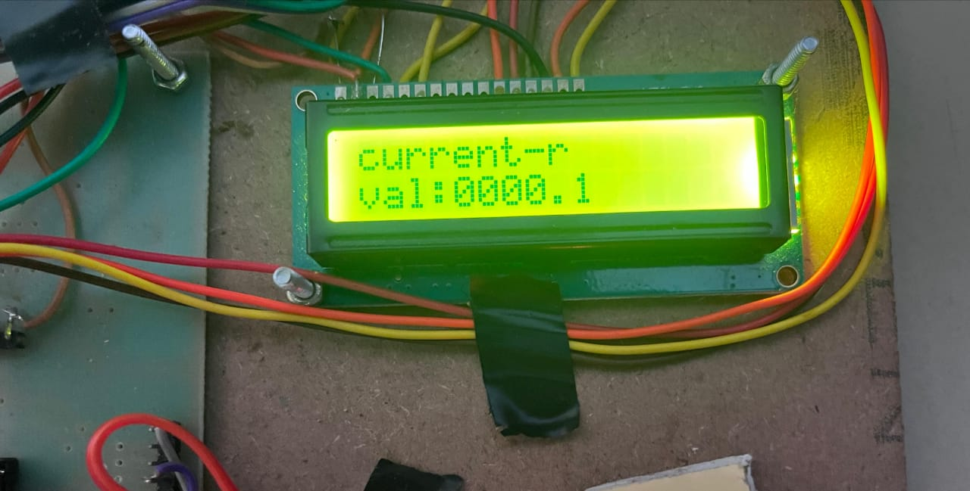
Fig.4.4.1 - Reading of the Current-r Sensor.

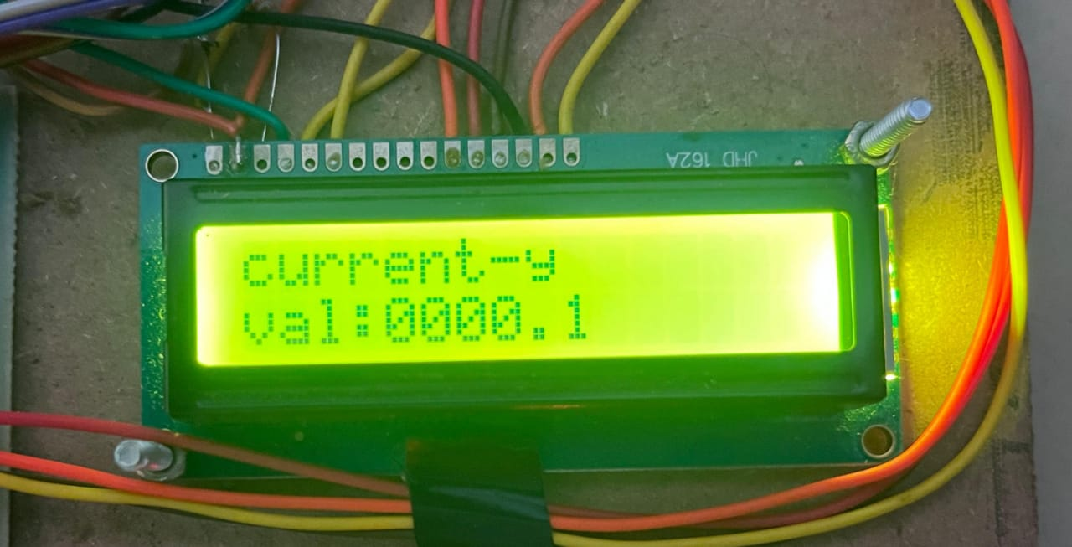
Fig.4.4.2 - Reading of the Current-y Sensor.

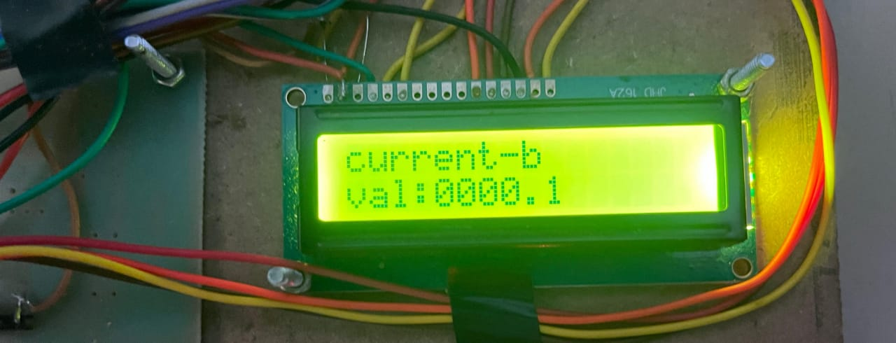
Fig.4.4.3 - Reading of the Current-b Sensor

Figure 4.5 shows the system displaying a real-time temperature reading on the LCD screen.
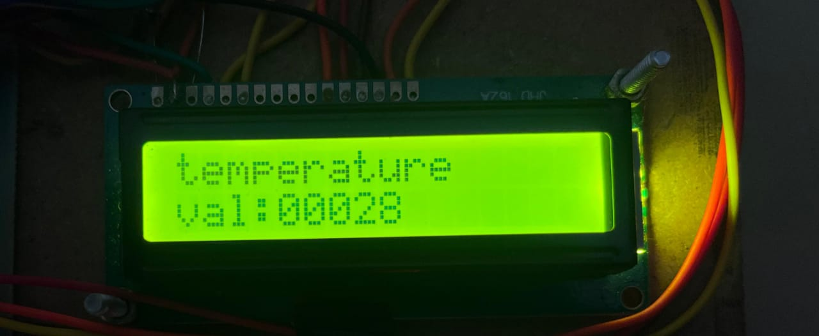
Fig.4.5 - Reading of the Temperature Sensor

Fig. 4.6 illustrates the Python-based Human-Machine Interface (HMI) developed for this study, which enables real-time acquisition and display of multi-sensor data via serial communication. The HMI continuously logs time-stamped sensor readings and automatically generates on-screen maintenance alerts in the event of detected phase faults, thereby supporting proactive system monitoring and reliability enhancement.
This implementation is integral to the predictive maintenance framework, ensuring effective fault diagnosis and continuous supervision of the electronic system.

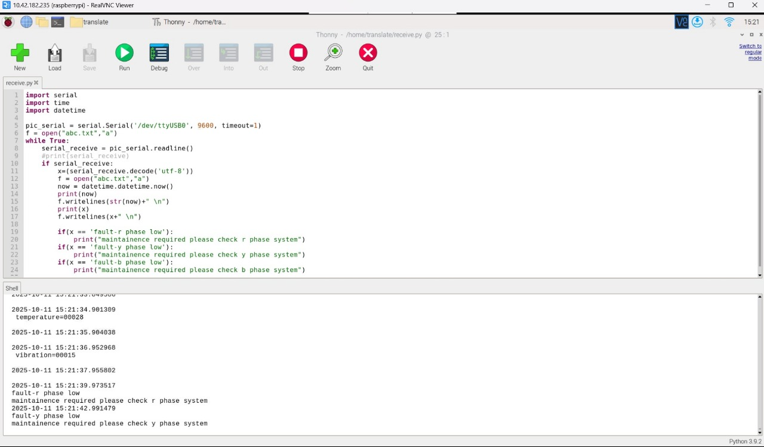
Fig 4.6 Real-time reading from the sensor.
The proposed monitoring system demonstrated accurate real-time detection and analysis of key motor parameters, proving effective for fault diagnosis and predictive maintenance. The integration of hardware and software facilitated seamless local and remote monitoring, enhancing operational reliability. Future work will focus on expanding sensor integration and refining data analytics to further improve system robustness and scalability.

- CONCLUSION
The developed system successfully demonstrates the seamless integration of the PIC18F4550 microcontroller with the Raspberry Pi, enabling efficient data acquisition, real-time processing, and intelligent monitoring of industrial motor health. The microcontroller is responsible for reading multiple analog and digital sensor inputs, converting them into engineering units, and displaying the processed data on an LCD for local visualization. At the same time, the Raspberry Pi handles advanced data management by storing readings, analyzing trends, and enabling connectivity with external platforms. This hybrid hardware–software approach ensures accurate fault detection, reliable communication, and timely decision-making, thereby establishing a practical and cost-effective foundation for predictive maintenance in industrial environments. Despite its effectiveness, the current system can be further enhanced to meet future requirements. Future work, such as integrating wireless communication technologies like Wi-Fi, Bluetooth, or LoRa, can eliminate the need for physical connections, enabling more flexible and scalable deployment. Additionally, cloud-based data logging and remote dashboards can provide continuous access to real-time sensor information, ensuring improved reliability, long-term storage, and global accessibility. Advanced machine learning and data-driven algorithms implemented on the Raspberry Pi can elevate the system from threshold-based detection to predictive fault diagnosis, offering early warnings and higher decision-making accuracy.
Furthermore, replacing the basic LCD module with a graphical user interface or touchscreen display would significantly improve visualization, user interaction, and operator friendliness. Collectively, these advancements would transform the prototype into a more robust, intelligent, and versatile monitoring solution. In conclusion, the present work not only validates the effectiveness of combining microcontrollers with high-performance computing platforms but also establishes a strong pathway for future improvements, ultimately leading to an industry-ready system capable of predictive, scalable, and intelligent fault monitoring.

REFERENCES

- Amorim, M. L. M., Lima, J. G., Torres, N. N. S., Afonso, J. A., Lopes, S. F., Carmo, J. P. P. d., Hartmann, L. V., Souto, C. R., Salvadori, F., & Ando Junior, O. H. (2024). Open-source data logger system for real-time monitoring and fault detection in bench testing. Inventions, 9(6), 120. https://doi.org/10.3390/inventions9060120
- Allegro Microsystems. (2022). ACS712 Current Sensor Datasheet. Allegro Microsystems LLC, Worcester, MA, USA. Retrieved from https://www.allegromicro.com/en/products/sense/current-sensors/acs712
- Analog Devices Inc. (2023). Thermistor temperature sensing system – Part 1: Fundamentals and circuit design. Analog Dialogue, Vol. 57, Issue 2. Retrieved from https://www.analog.com/en/resources/analog-dialogue/articles/thermistor-temperature-sensing-system-part-1.html
- Chen, Y., & Zhou, M. (2021). Fault detection of induction motors based on real-time vibration data and deep learning techniques. IEEE Transactions on Industrial Informatics, 17(12), 8243–8252. https://doi.org/10.1109/TII.2021.3098779
- Microchip Technology Inc. (2003). PIC18F4550 8-bit Microcontroller Datasheet (Rev. C). Microchip Technology, Chandler, AZ, USA. Retrieved from https://www.alldatasheet.com/datasheet-pdf/pdf/93911/MICROCHIP/PIC18F4550.html
- Nandhini, R., & Rajasekar, R. (2022). IoT-based predictive maintenance for industrial motors using vibration analysis. International Journal of Advanced Computer Science and Applications (IJACSA), 13(4), 105–111.
- Patel, K., & Mehta, D. (2020). Raspberry Pi-based real-time monitoring system for motor health assessment. Journal of Instrumentation and Control Engineering, 8(3), 45–50.
- Singh, V., & Sharma, P. (2023). Implementation of a low-cost IoT system for condition monitoring of electric motors. IEEE Access, 11, 70521–70530. https://doi.org/10.1109/ACCESS.2023.3270452
- Zhang, L., & Li, H. (2022). Integration of machine learning for predictive maintenance in industrial automation. Sensors, 22(10), 3724. https://doi.org/10.3390/s22103724
- Bhosale, A., & Kadam, S. (2021). Design and development of an embedded fault detection system using Raspberry Pi. International Journal of Electronics and Communication Engineering, 9(2), 78–85.

